**Quick Start Finance - Programming Journal**

**25JAN23: First Entry - Project Proposal**

**Link to Project Proposal document:** [Capstone Project Proposal](https://docs.google.com/document/d/106bV6xiJ_oVQ74e4kXi6avEoCzRkrBR6fxIfPzwysi4/edit?usp=sharing)

**Application title: Quick Start Finance** – ***A “Younger” Personal Finance Application***

**Purpose**: The purpose of the Quick Start Finance application is to enable young users to track their personal budgets of income and expense in an easy-to-read, simple, light-weight manner.

**Program procedures**: The Quick Start Finance application will enable users to create a personal account. The personal account will include username, birthday, phone, address and password. Then the user may login into a dashboard. Within the personal dashboard, the user will then be able to enter individual income records, including income title/name, categories, date of income, income amount and description of the income record. Likewise, the user will be able to enter the same details for expenses. There will be a navigation menu that will allow the user to easily view the dashboard, income page, expense page, as well as tabs to view income/expense records and totals, and finally to logout.

**Target Client**: This application is mainly targeted toward young, college age individuals who want to get started tracking their money without too much complication or confusing financial numbers (things that may be important later in life). It will enable teenagers and early twenty-somethings to gain some financial literacy and understand the arithmetic of incoming money and outflowing expenditures to help prepare for getting on their own, before their personal “checkbooks” and financial statements become too complicated.

**Notes and restrictions**: This application may be of use to older users for the simple transactions mentioned above. However, it has limited application and would not be a good fit for someone with complex needs, such as investments, retirement, taxes or asset reporting. The user will not see income statements or balance sheets. Indeed, mature users may find the interface even childish or naïve. Again, we are specifically targeting the youth.

**Comments**: Our hope at the Quick Start Finance Company is to urge young people to begin taking stock of their financial situation and ease them into a life of financial literacy.

**26JAN23: Second Entry - Project Proposal Presentation**

**Link to Project Proposal Presentation:** [Quick Start Finance - Project Presentation](https://docs.google.com/presentation/d/1oxM4Nl0Wy-VjRvQ3P1Fmfw_QTj7ak6STuHAaKPWx6TY/edit?usp=sharing)

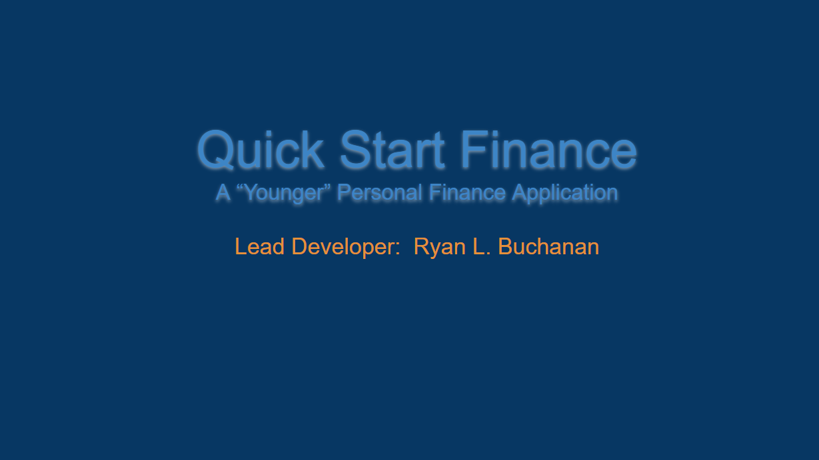

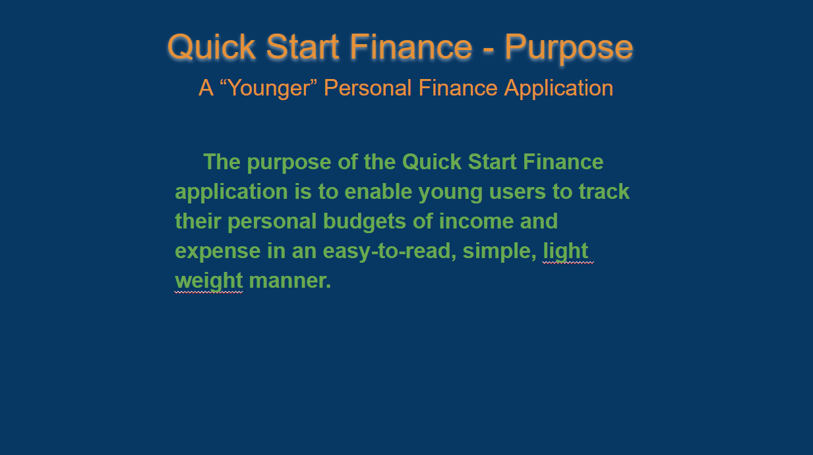

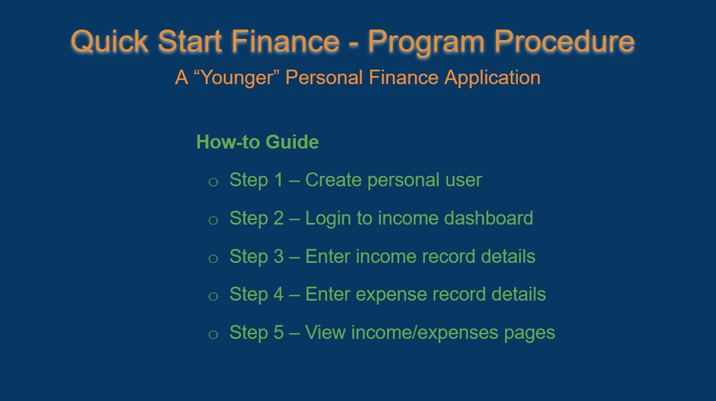

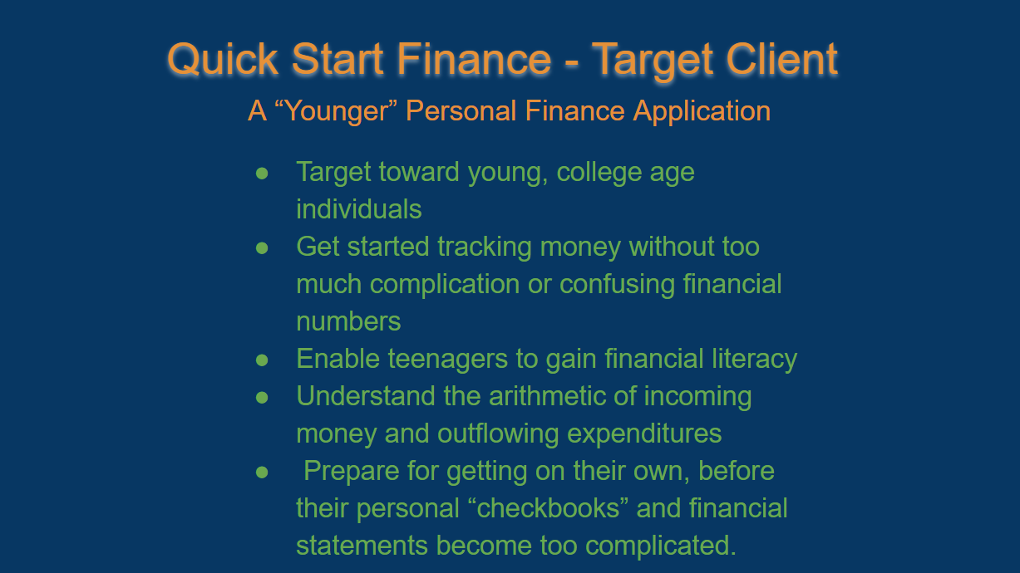

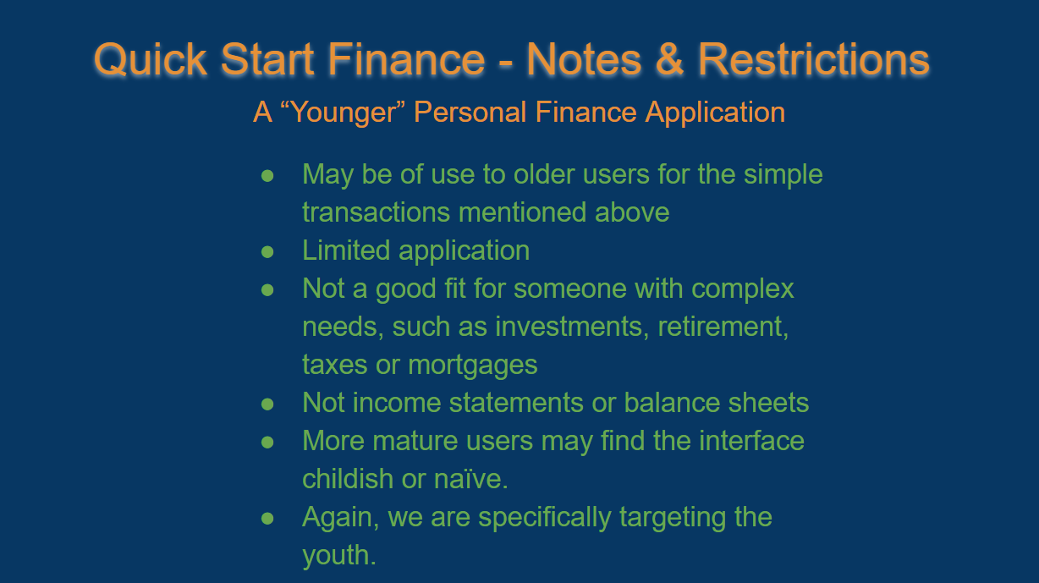

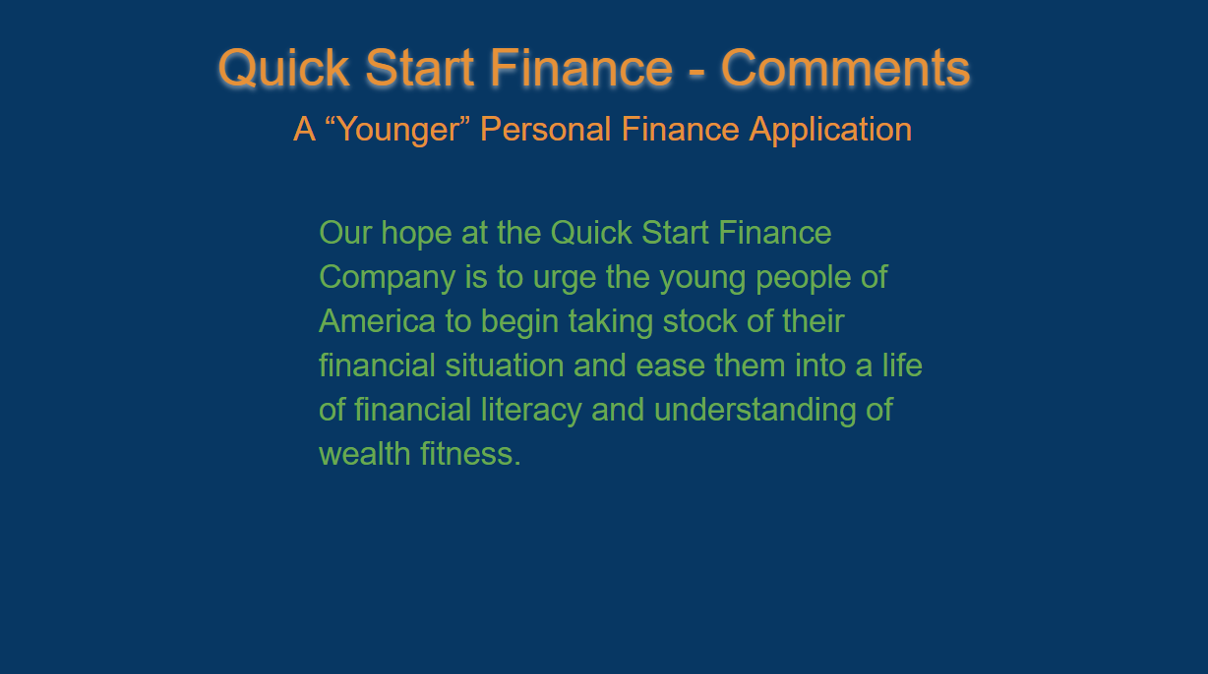

**27JAN23: Third Entry - Wireframing and Initial GUI Prototype Sketches**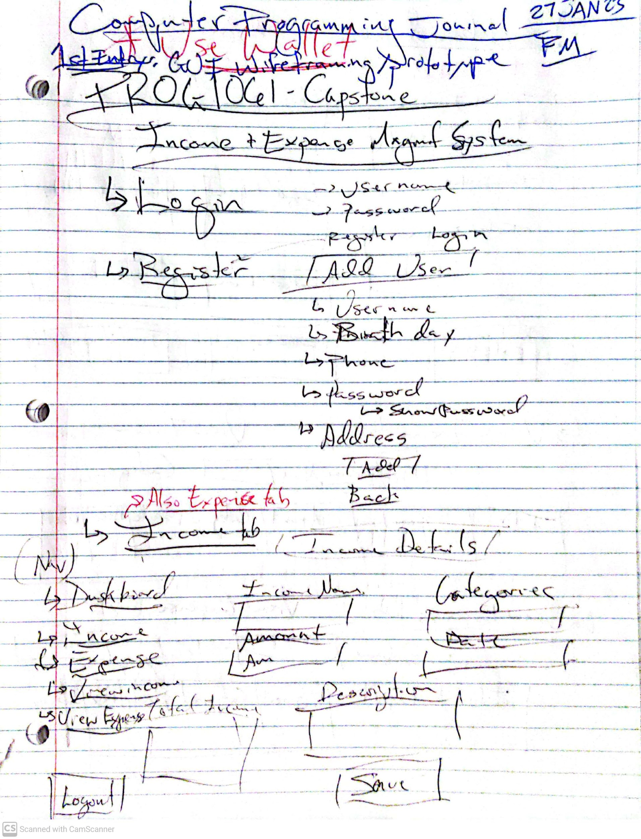

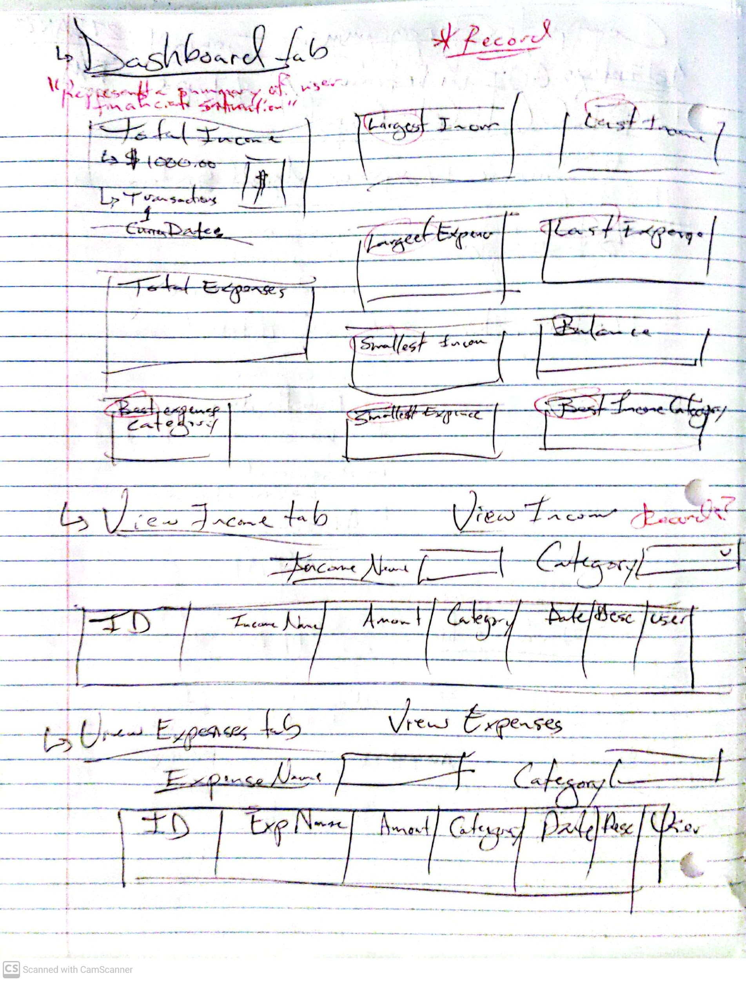

**28JAN23: Fourth Entry - Github repository - “Quick_Start_Finance”**

**Link to Github repository:** [**https://github.com/RyanLBuchanan/Quick_Start_Finance**](https://github.com/RyanLBuchanan/Quick_Start_Finance)

**28JAN23: Fifth Entry - Trello Board - “Quick Start Finance”**

**Link to Trello board:** [**https://trello.com/invite/b/2RBNMqV2/ATTI81e07296f9dc3ad7cc89dd029d0a029b2DDAFDEA/quick-start-finance**](https://trello.com/invite/b/2RBNMqV2/ATTI81e07296f9dc3ad7cc89dd029d0a029b2DDAFDEA/quick-start-finance)

A great start! Project feels fully initiated.

**28JAN23: Sixth Entry - Module 2: Deliverable I**

Deliverable I includes:

1. Trello board “Quick Start Finance link: <https://trello.com/invite/b/2RBNMqV2/ATTI81e07296f9dc3ad7cc89dd029d0a029b2DDAFDEA/quick-start-finance>
2. Github “Quick_Start_Finance” repository link: <https://github.com/RyanLBuchanan/Quick_Start_Finance>
3. Zipped folder containing:
   1. Visual Studio beginning of “Quick_Start_Finance”
   2. Dashboard Winforms form and C# script
4. Quick Start Finance Login and Dashboard wireframes (below):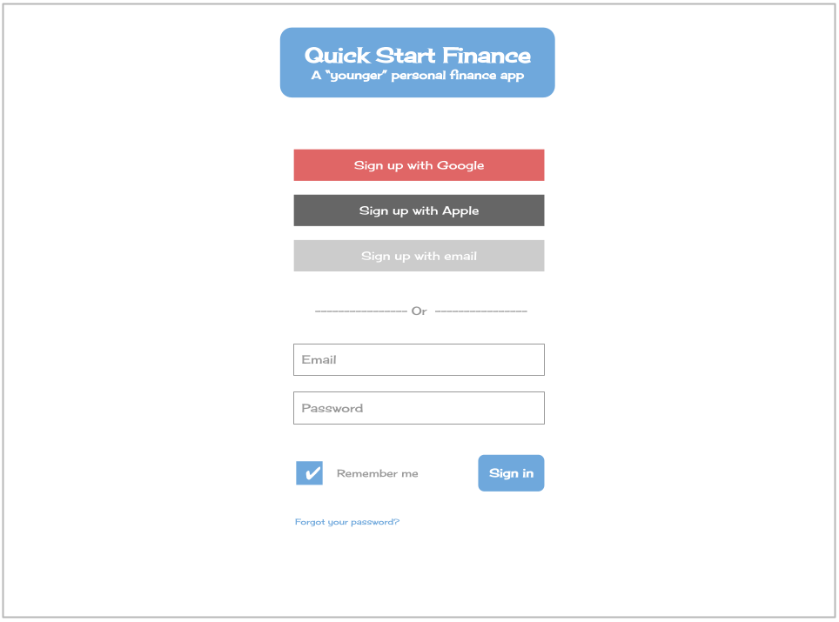

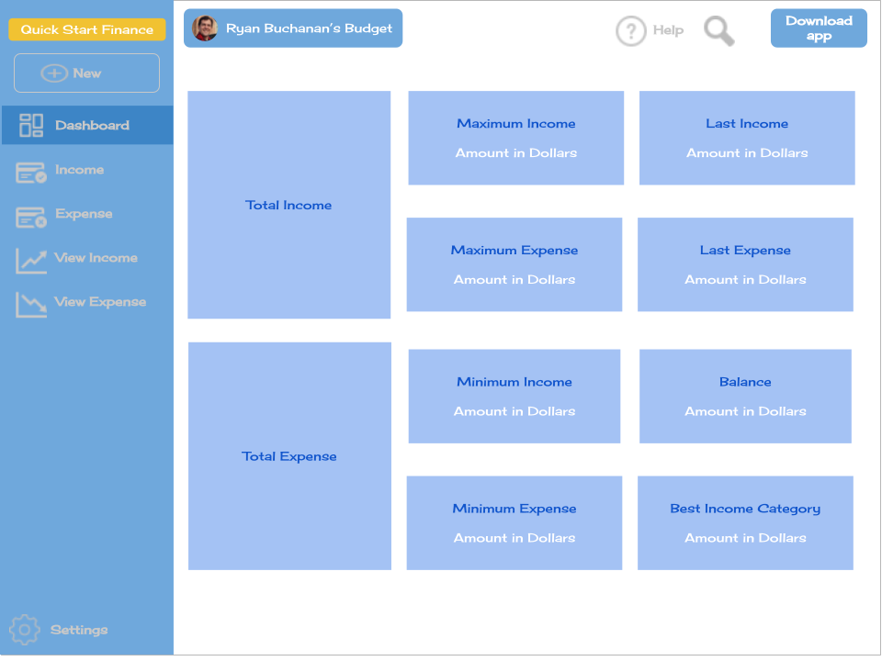

**28JAN23: Seventh Entry - Module 3: Deliverable II**

1. Turned in Module 2 with initialized VS project and winforms dashboard template.
2. Completed NavPanel in winforms Dashboard.
3. Looks excellent! (below):

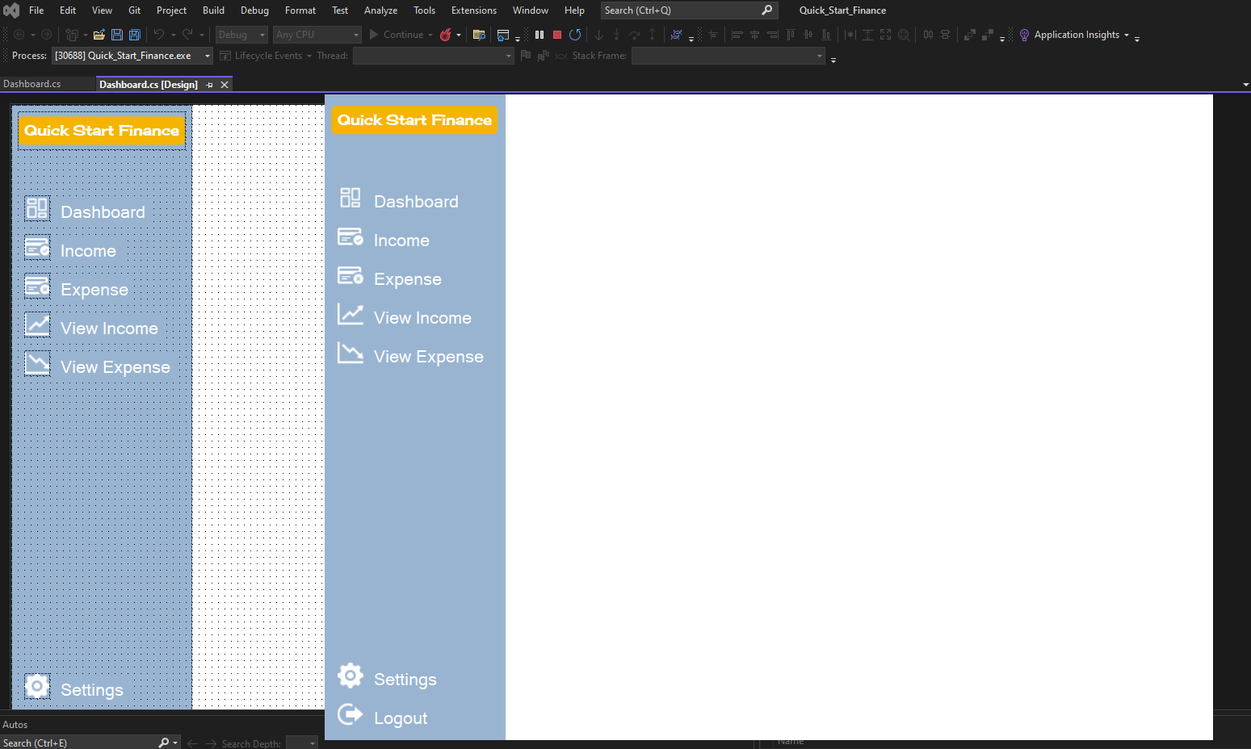

**29JAN23 AM: Eighth Entry - Module 3: Deliverable II continued**

Continue work on initial Quick Start Finance dashboard. Will complete all GUI design and back-end code and turn in today.

**29JAN23 MIDDAY: Ninth Entry - Module 3: Deliverable II continued**

Completed Personal Finance Dashboard GUI and moved on to Personal Income Records GUI

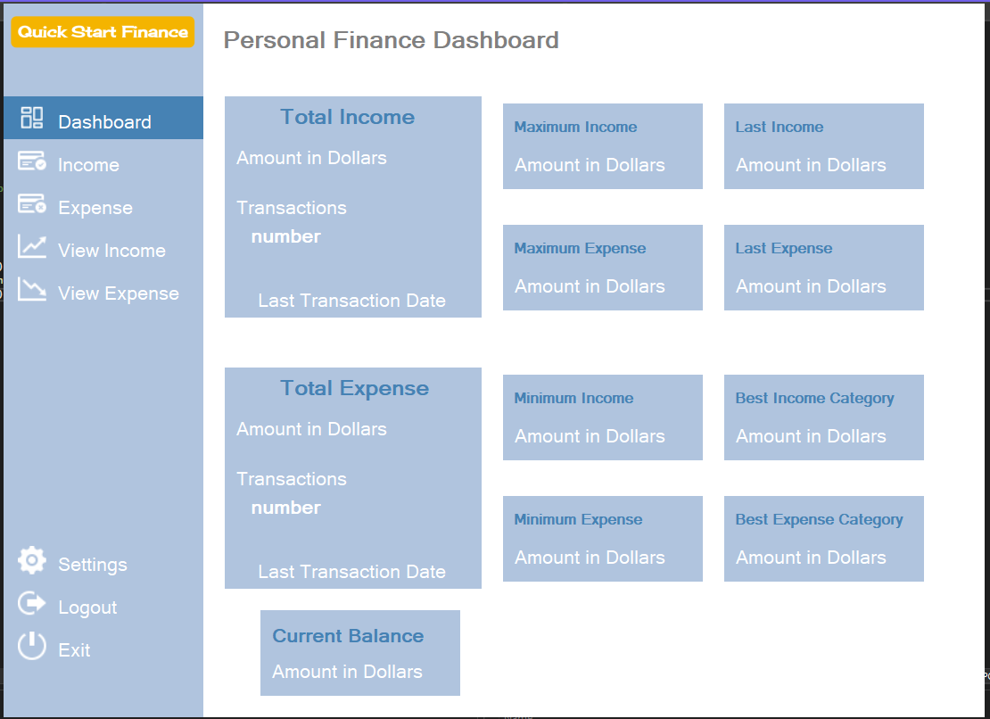

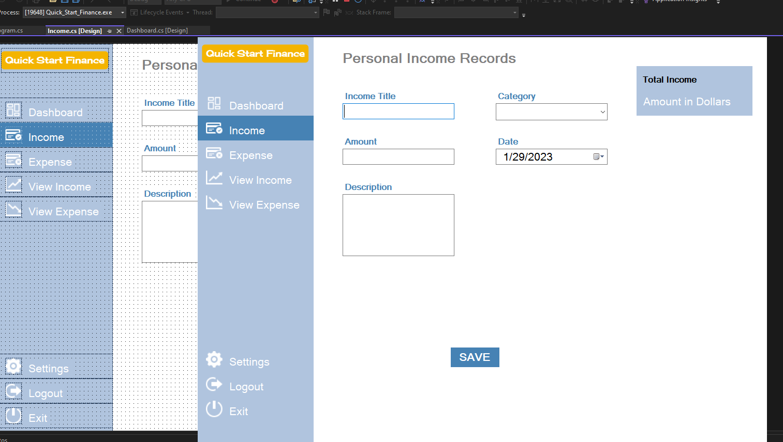

**30JAN23 AM: Tenth Entry - Project Proposal Completion**

Completed Project Proposal presentation with David. Quick Start Finance officially approved.

Presentation Notes:

* “Google generation finance app
* Fundamental design flaw (after viewing GUI prototype), Dashboard too complicated for kids today . . . dumb down - normal kids language.
* Show it to cosmetology
* Also, should be mobile, not Desktop or web re kids today
* Re mobile design for Visual Studio: checkout Xamarin and Navi mobile development
* Perhaps should have interactive tutorial for kids
* “Clippy” from Microsoft
* Perhaps tooltip step through as it loads first time?
* Gen Z speech main point

**31JAN23 AM: 11th Entry - Turn in Module 3 Deliverable II**

Turned in Module 3: Deliverable II including:

* Updated QSF programming journal
* Updated “Quick_Start_Finance” Visual Studio winforms project
  + Completed Dashboard GUI
  + Completed Income Records GUI
* Completed jpegs of Dashboard GUI and Income Records GUI

**31JAN23 AM: 12th Entry - Began Module 4 Deliverable II**

Completed GUIs for New Expense Details and revision of Dashboard and New Income Details GUIs

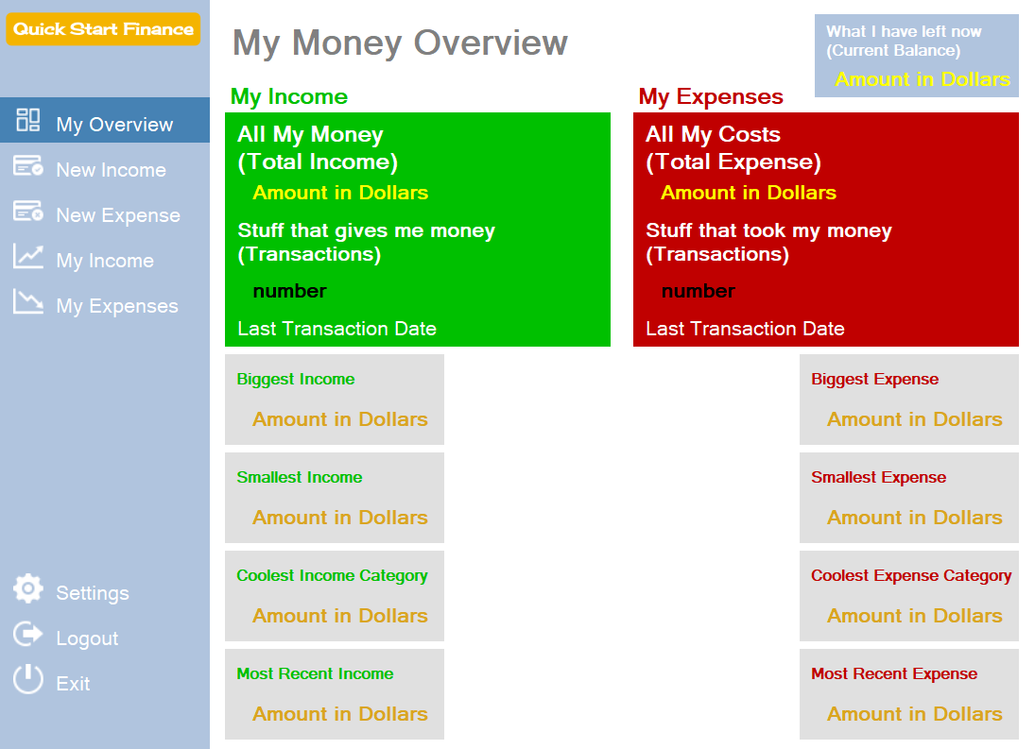

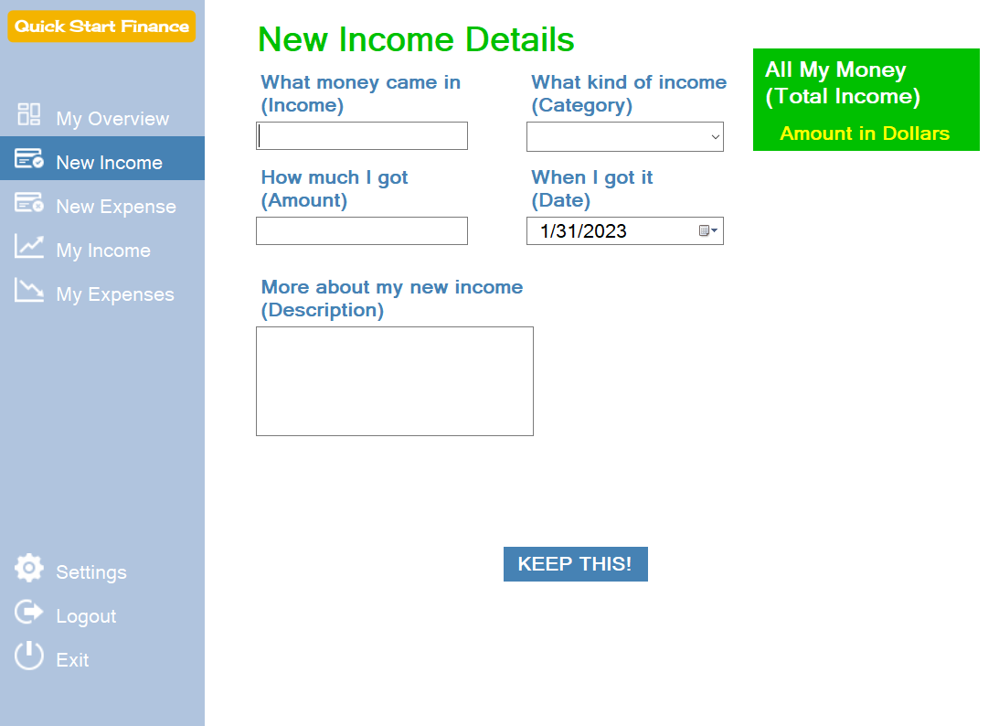

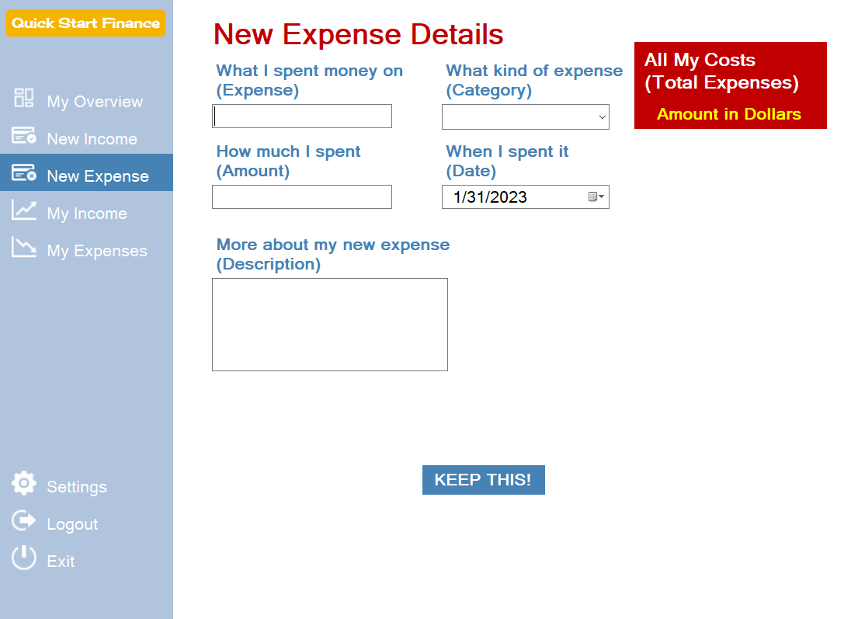

Revisions include changes suggested by David to create a more Gen Z friendly dialogue, increase in font size and primary colors added.

**01FEB23 AM: 13th Entry - Began Module 4 Deliverable III**

Revised UI to use a gentler the RGB parameters of Google’s color scheme: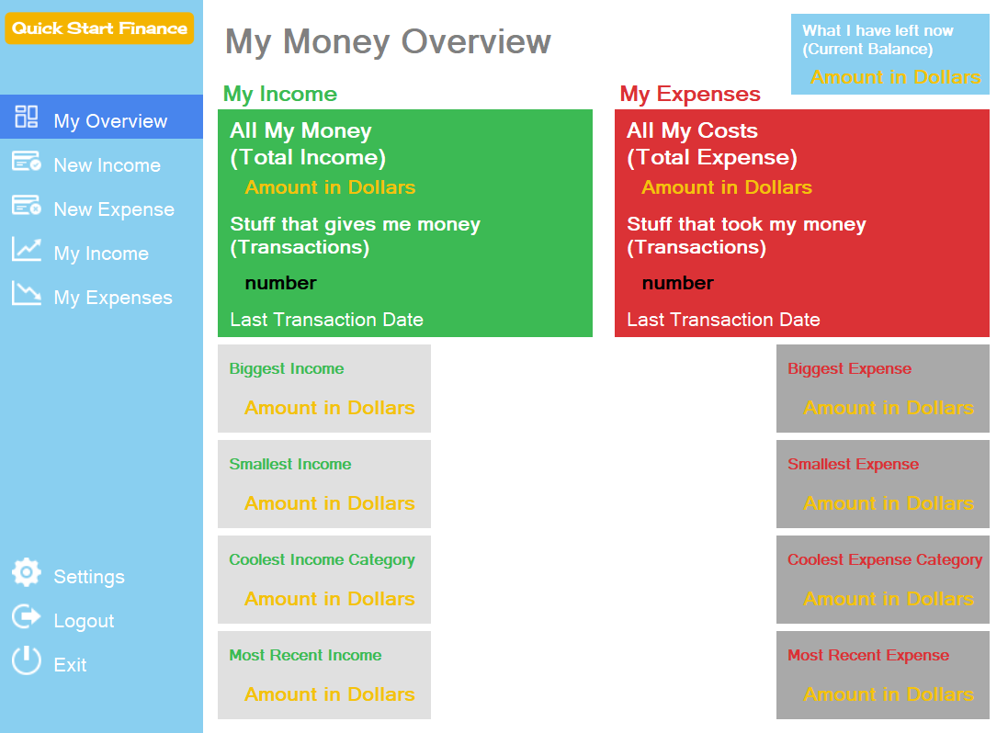

**Before: After:**

It’s a little easier on the eyes.

**02FEB23 AM: 14th Entry - Completed Module 4 Deliverable III**

Completed and submitted Module 4 - Deliverable III includes:

* Updated Programming Journal
* All completed and revised Quick Start Finance GUIs
  + Dashboard GUI
  + New Income Record GUI
  + New Expense Record GUI
  + View Income Records GUI
  + View Expense Records GUI
  + Login GUI

Screenshots of current GUI iteration: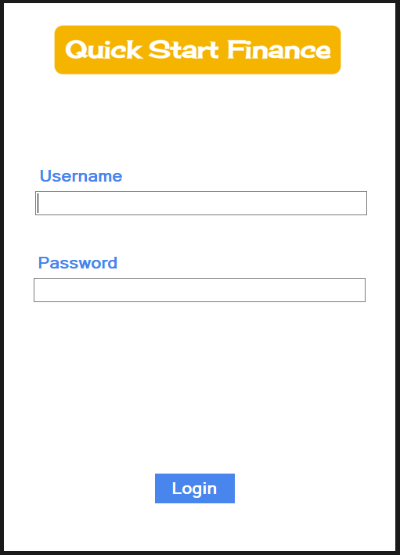

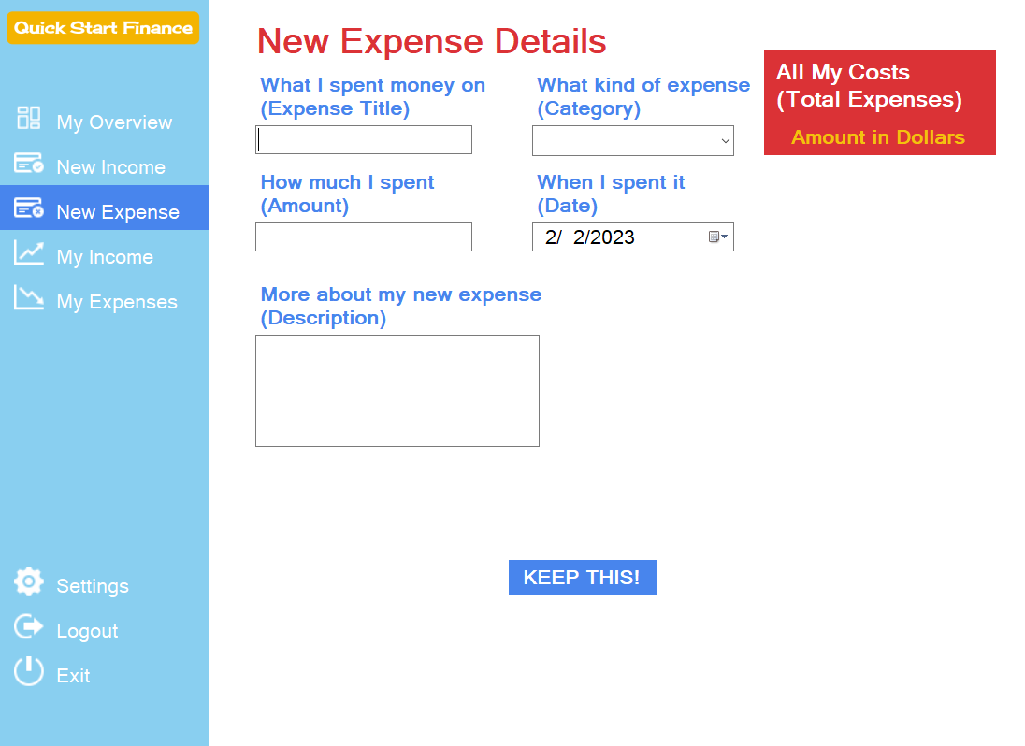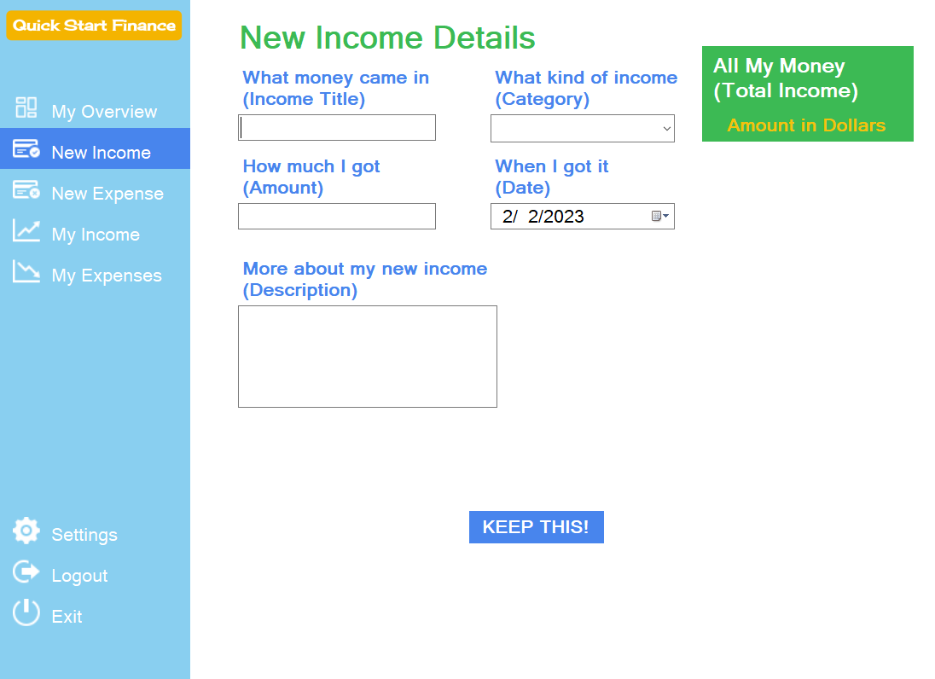

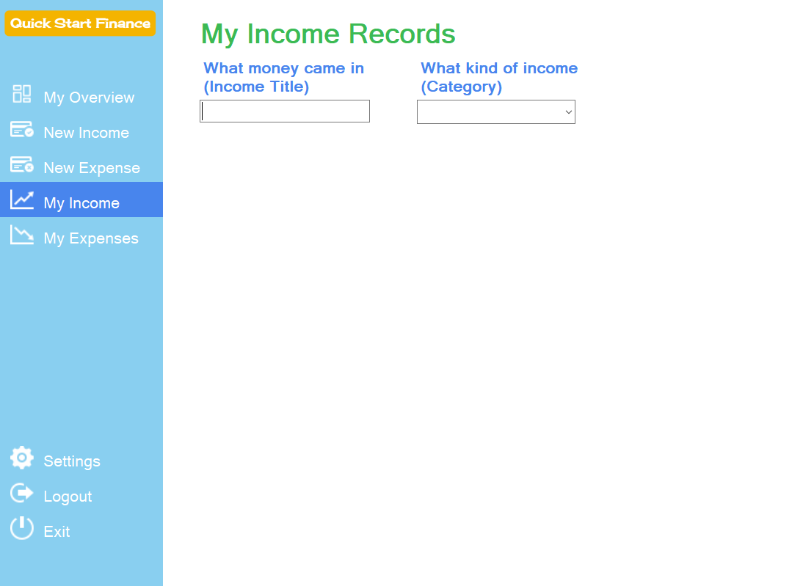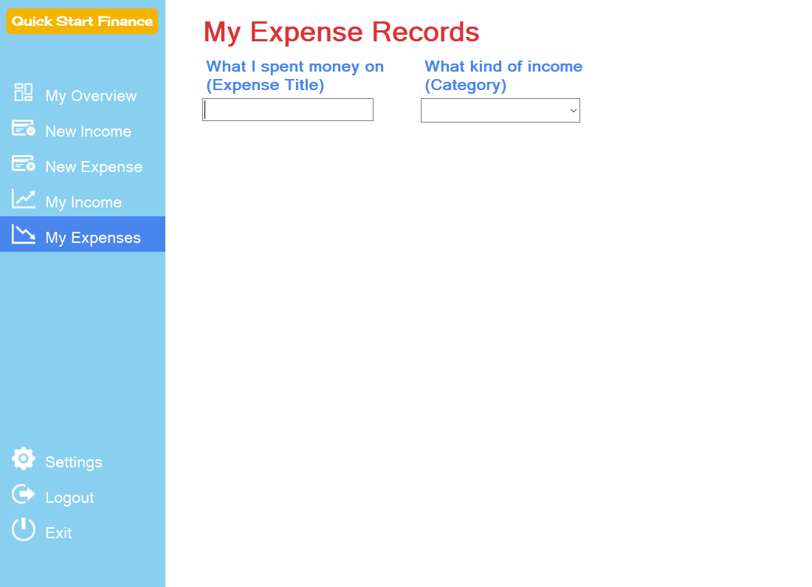

**02FEB23 AM: 15th Entry - Started Module 5 Deliverable IV**

Created Quick Start Finance database (“QSFDb”) within Server Explorer view of Visual Studio. Added script to be handed in with Deliverable IV.

Started Users GUI and C# scripting.

Completed Users GUI:

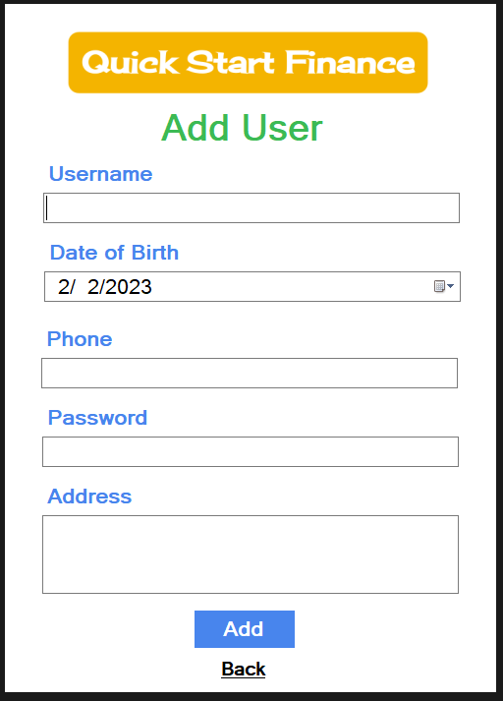

Completed code for “Add User” registration (see walkthrough):



**02FEB23 PM: 16th Entry - Continued Module 5 Deliverable IV**

Added navigation bar code to Dashboard:



**ERROR: Discovered syntax error in trying to access User from login to be added to Income table.**

**Will solve in the morning and turn in Deliverable IV**

**03FEB23 AM: 17th Entry - Completed Module 5 Deliverable IV**

Completed and submitted Module 5 Deliverable IV.

Includes:

* Updated Programming Journal
* Initial C# scripting for:
  + Dashboard -> Dashboard.cs
  + Login -> Login.cs
  + Add User GUI -> Users.cs
  + New Income Record GUI -> Income.cs
* SQL Server queries to create necessary tables:
  + UserTbl
  + IncomeTbl
  + ExpenseTbl
* Walkthrough demonstrations of:
  + Add User
  + Login
  + Valid login and navigation

**03FEB23 AM: 18th Entry - Started Module 6 - Deliverable V**

This will involve completing all scripting for interaction between User and adding new income/expenses and viewing income/expenses records.

Corrected syntax error in SQL query (changed ‘User’ in Income table to ‘Username’) and created initial code for add new income record:



Created initial code for income records view:



Completed initial scripting for add new expense record:



Completed initial View Income/Expense C# scripting".



Completed initial dashboard totals C# scripting:



Completed Dashboard except 'Coolest' stats

**04FEB23 AM: 19th Entry - Complete Module 6 - Deliverable V**

Today will complete all coding for Version 1.0 of Quick Start Finance!

Completed all statistics reports for Dashboard:

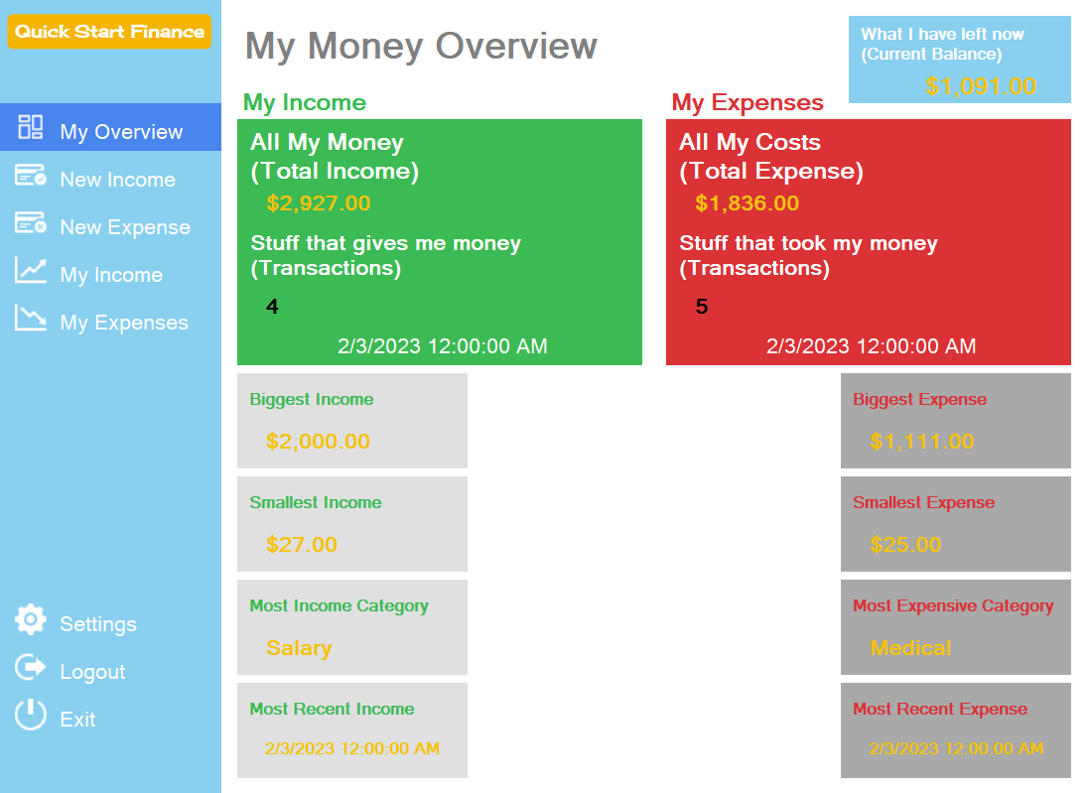

Completed all C# scripting and GUI design for fully functional Quick Start FInance application.

Completed and submitted Module 6 Deliverable V.

Includes:

* Updated Programming Journal
* Complete Initial C# scripting for:
  + Dashboard -> Dashboard.cs
  + Login -> Login.cs
  + Add User GUI -> Users.cs
  + New Income Record GUI -> Income.cs
  + New Expense Record GUI -> Expense.cs
  + My Income Records View -> ViewIncome.cs
  + My Expense Records View -> ViewExpense.cs
* Walkthrough demonstrations of:
  + Add new income record
  + Add new expense record
  + Dashboard totals
  + View income records
  + View expense records
  + Full application walkthrough
* Zipped “Quick_Start_Finance-Deliverable_V” complete Visual Studio project
* Trello board “Quick Start Finance link: https://trello.com/invite/b/2RBNMqV2/ATTI81e07296f9dc3ad7cc89dd029d0a029b2DDAFDEA/quick-start-finance
* Github “Quick_Start_Finance” repository link: https://github.com/RyanLBuchanan/Quick_Start_Finance

**04FEB23 PM: 20th Entry - Started Module 7 - Deliverable VI**

Completed successful functional Desktop Quick Start Finance.

Now, researching creating an Android app with Xamarin in Visual Studio.

**05FEB23 PM: 21st Entry - Started Xamarin Project for QSF**

Found many wonderful tutorials.

Including:

* [Xamarin Tutorial for Beginners - Build iOS & Android Apps with C#, Visual Studio, and Xamarin.Forms](https://youtu.be/zvp7wvbyceo)
* [Build Your First Android App with Visual Studio 2019 and Xamarin](https://www.youtube.com/watch?v=I0D3JIYFljE&t=2s)
* [Set Up Device for Development](https://learn.microsoft.com/en-us/xamarin/android/get-started/installation/set-up-device-for-development)

Xamarin development is possible and can be achievement but currently it seems to error right out of the box with even it’s simplest templates:

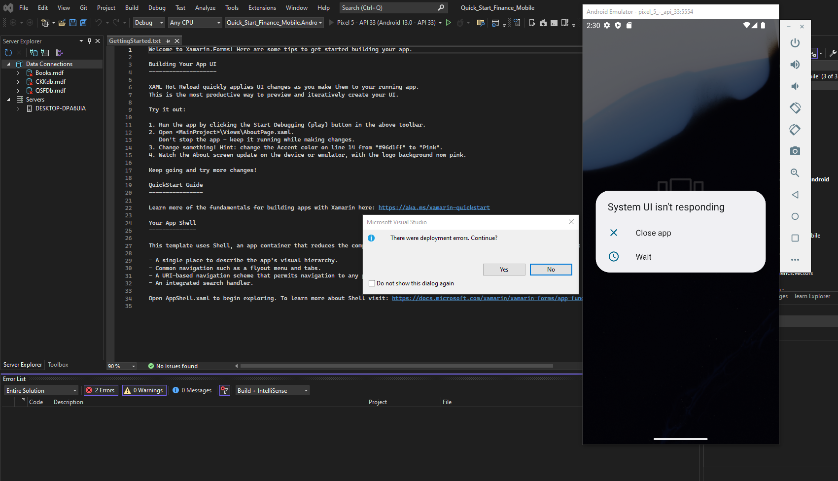

Given more time (I am now employed with Revature and to complete it I must work evenings and weekends which distracts from and is counter-productive to optimal Revature employment), I could definitely get it to work.

As it is, I must complete this capstone and move on to the purpose for which I began this program -> to get a job and do well at it.

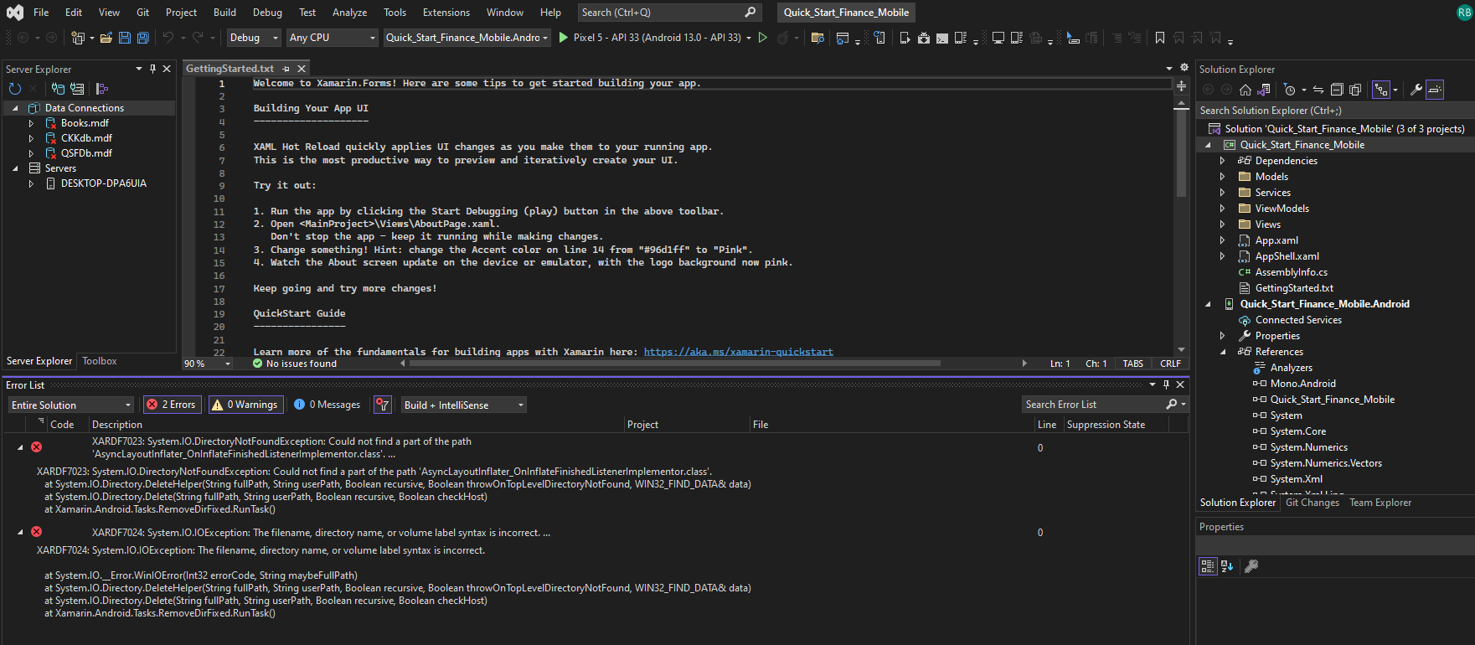

Began googling solutions to these errors and found weekend work time slipping away.

Choose to abort Xamarin mobile development for now and complete desktop documentation and presentation.

**06FEB23 AM: 22nd Entry - Retry Xamarin for QSF and completing final presentation**

Published QuickStartFinance.

Installed and ran successfully on Laptop.

Completing final presentation, documentation and demonstration - scheduled presentation for Tuesday, 07FEB23 between 8-11am.

Completed documentation and tutorial walkthrough.

Created a website to download QSF app and documentation and view walkthrough gif for presentation:

<https://www.ryangineer.com/quickstartfinance>